Ever wondered what really happens when you hit Run in a Databricks notebook?
Let’s take an example:
df = spark.read.csv("/mnt/data/sales.csv")
df.filter("amount > 1000").groupBy("region").sum("amount").show()
Looks simple, right? But behind .show(), Spark plans, optimizes, and executes your code across a distributed cluster with maximum speed 🚀
⚙️ Step 1: Cluster Setup
A Databricks cluster has:
🧠 Driver Node → Coordinates everything
💪 Executor/Worker Nodes → Do the work
🎛️ Cluster Manager → Allocates resources
Databricks manages this automatically — you just pick the instance type and run your notebook.
⚙️ Step 2: SparkSession — Entry Point
from pyspark.sql import SparkSession
spark = SparkSession.builder.appName("SalesAnalysis").getOrCreate()
SparkSession connects to the cluster & manages configurations. All operations (spark.read
, df.filter, spark.sql) flow through it - the gateway to Spark.
🧠 Step 3: Driver Builds Logical Plan
df = spark.read.csv("/mnt/data/sales.csv")
Spark doesn’t read the file yet - it creates a logical plan, a blueprint of operations.
Lazy evaluation ensures nothing executes until an action triggered.
🧩 Step 4: Transformations - Build the Plan
df.filter("amount > 1000").groupBy("region").sum("amount")
Each transformation adds to the logical plan: Read CSV → Filter → GroupBy → Sum
⚡ Step 5: Catalyst Optimizer
Improves logical plan by:
✅ Pushing filters near data source
✅ Removing unused columns
✅ Optimizing joins & aggregations
Result → an optimized logical plan ready for execution
🧱 Step 6: Physical Plan & DAG
Spark converts the optimized logical plan into a physical plan (how to execute it). This plan becomes a DAG (Directed Acyclic Graph) — tasks and their dependencies.
DAG Scheduler takes DAG & splits into Jobs → Stages → Tasks for parallel execution.
Ex DAG:
Read CSV → Filter → GroupBy → Aggregate → Show
🔄 Step 7: Execution
🦥 Lazy Evaluation → Spark only executes when an action like .show() or .write() is triggered. Until then, everything is just planning and optimization.
Job → The action (.show(), .write).
Stage → Group of dependent tasks. Read, Filter, Aggregate
Task → Smallest unit of work (runs on each partition)
Executes multiple tasks in parallel, one per partition.
💪 Step 8: Executors Work
Each executor:
Reads its partition
Applies transformations
Sends results to the driver
Parallel execution = Spark’s Distributed power ⚡
🧩 Step 9: Collect Results
Driver merges partial results:
.show() → displays output
.write.format("delta").save() → writes to ADLS Gen2 / Delta Lake
🏁 Summary
🧠 Driver → Builds logical & physical plans
🎛️ Cluster Manager → Allocates resources
💪 Executors → Execute tasks in parallel
✨ DAG → Backbone for task scheduling
⚡ Catalyst Optimizer → Optimizes queries for speed & efficiency
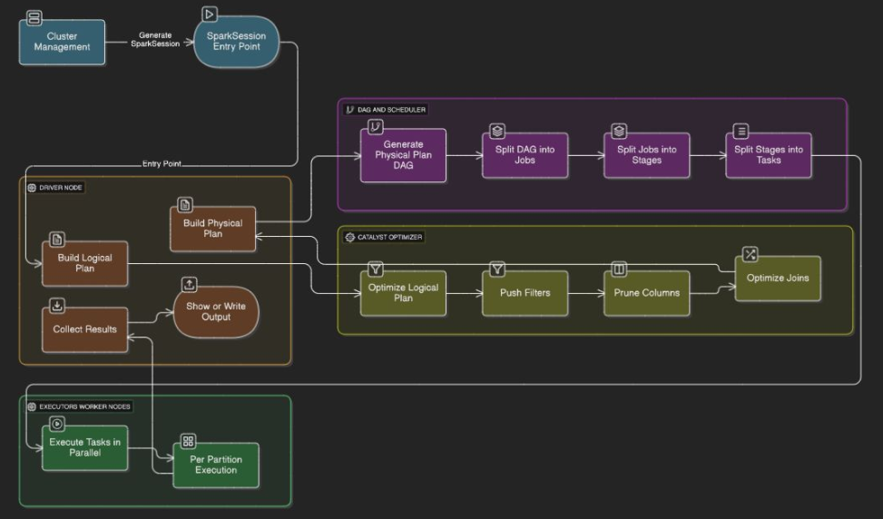

⭐ How Databricks Executes Code:
1. When we run code in the Notebook UI, it is first sent to the Driver node (Spark Driver).
2. The Driver parses the code to build a logical plan, then constructs a DAG where all transformations are recorded lazily.
3. Execution starts only when an action is triggered — the DAG Scheduler then splits the DAG into stages based on shuffle boundaries.
4. The Task Scheduler converts each stage into multiple tasks (one per data partition) and dispatches them to executors on worker nodes.
5. Executors run tasks in parallel to perform computation and read/write operations using hashtag#PySpark / hashtag#Spark, returning partial results to the Driver, which aggregates and sends final output back to the notebook across hashtag#DistributedComputing clusters.
💡 Key takeaways:
✅ Transformations are lazy — execution only starts when an action is called
✅ Driver handles planning, scheduling & coordination
✅ Executors (workers) execute tasks in parallel
👉 Databricks Execution Journey:
Activate to view larger image,
